
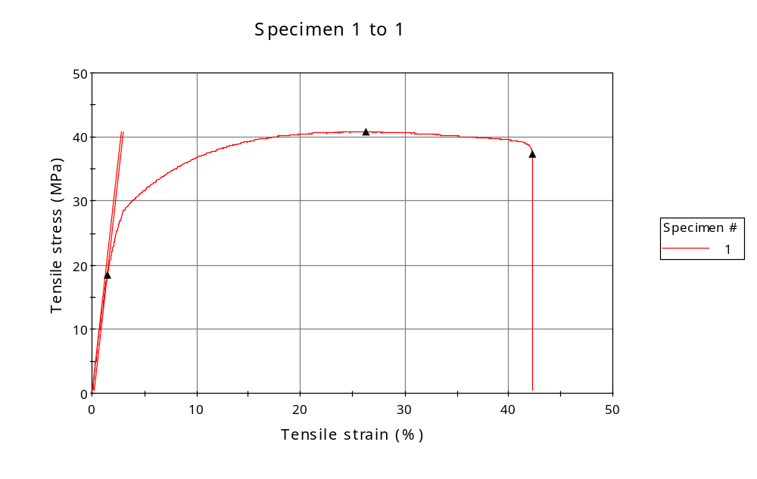
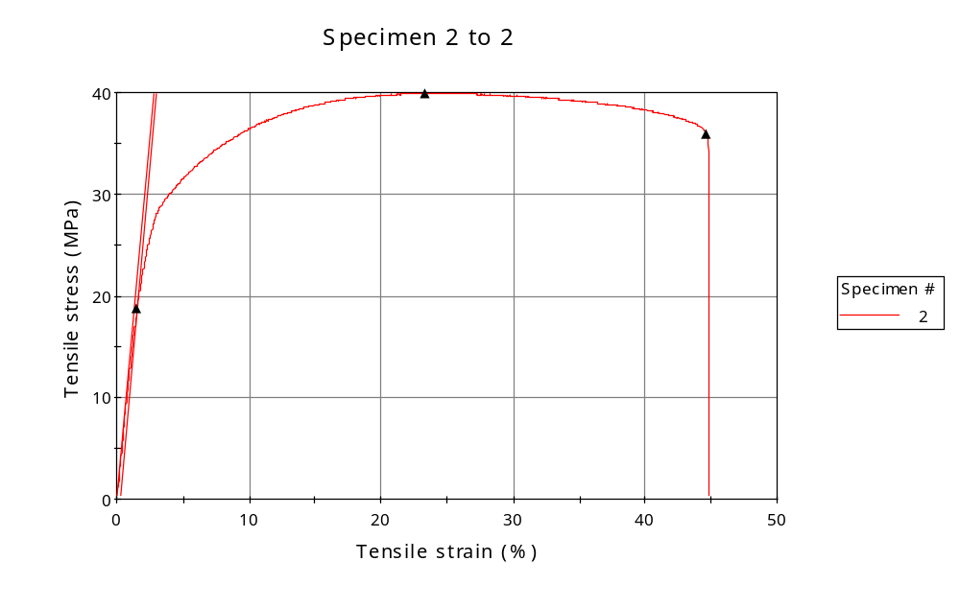
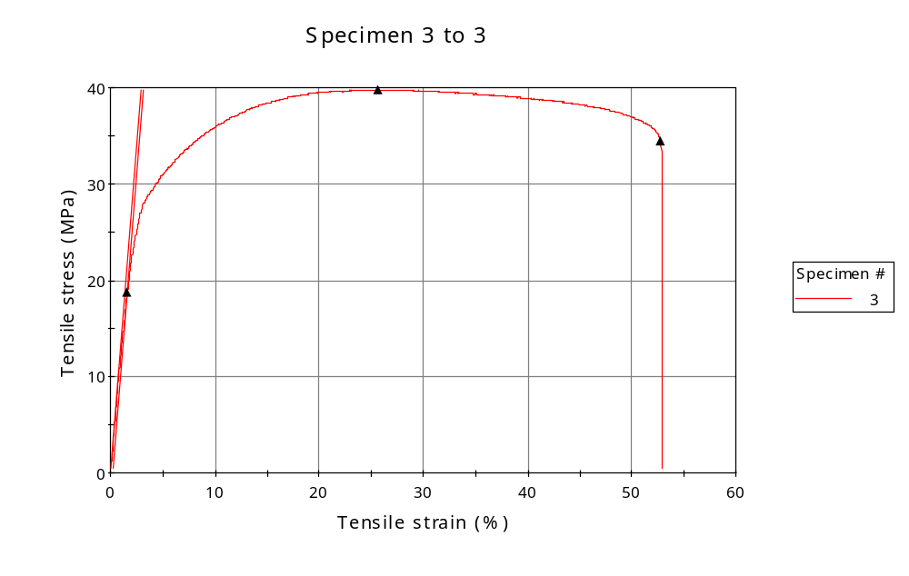
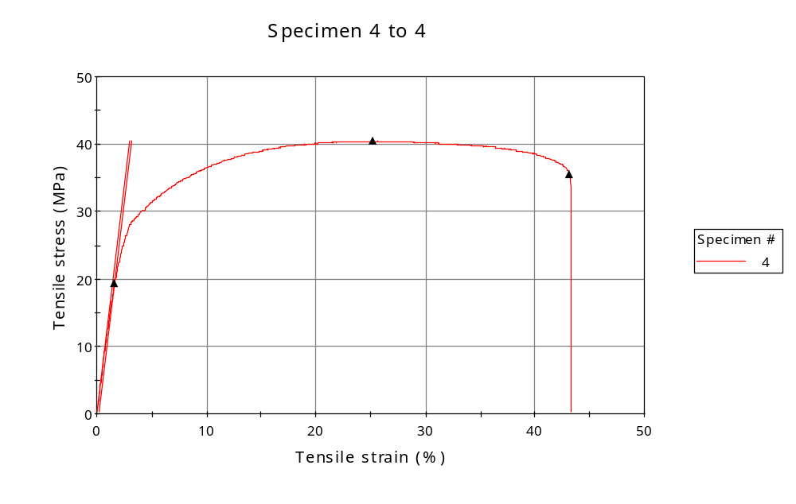
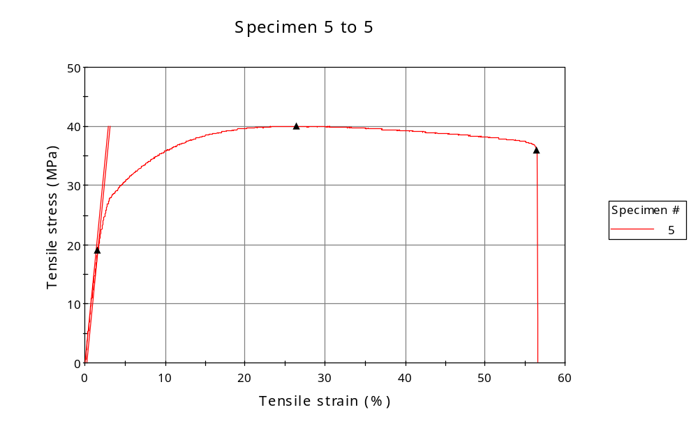
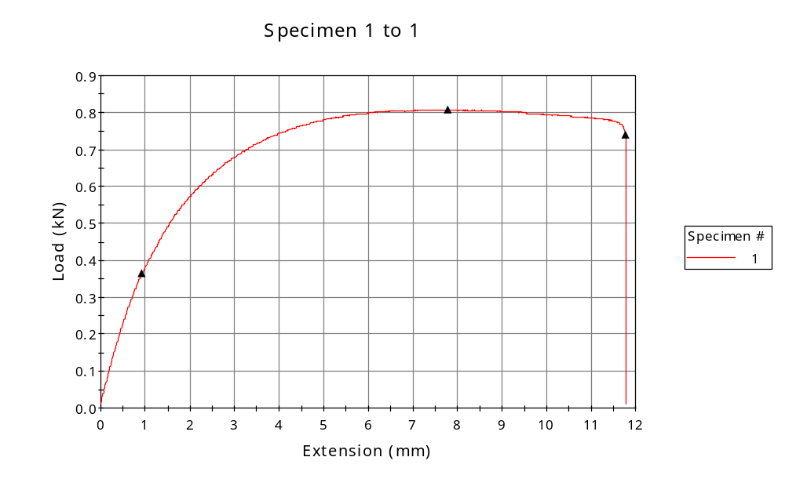
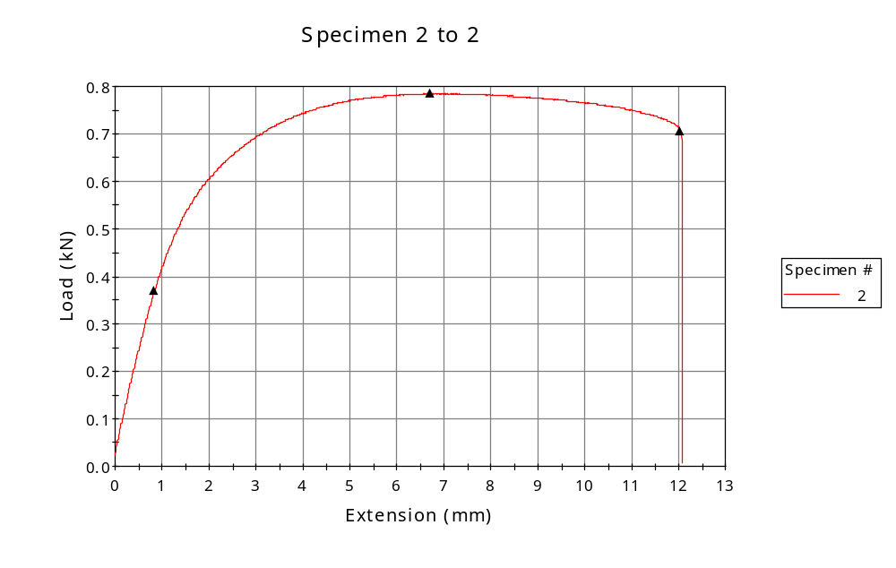
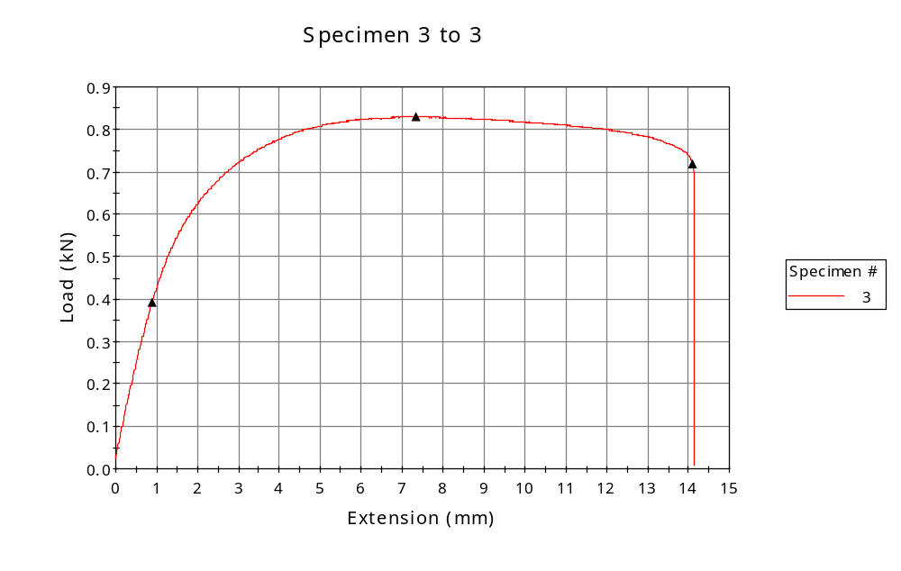
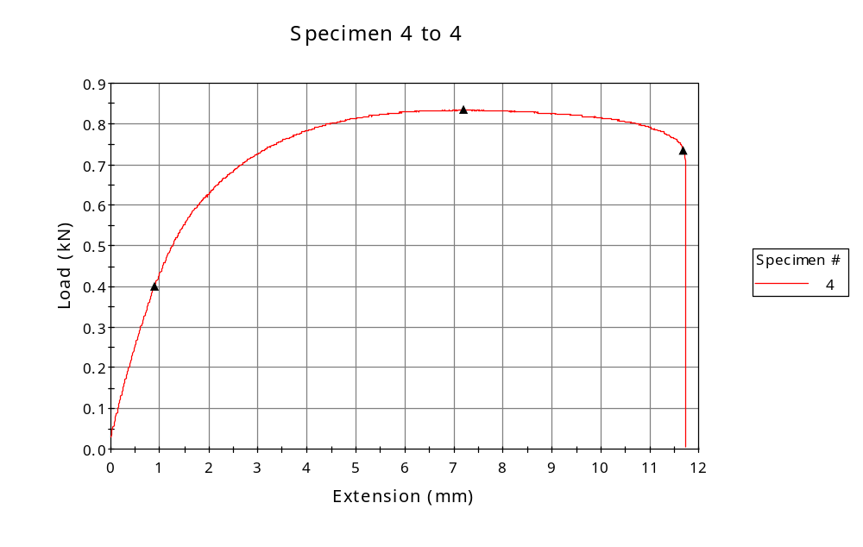
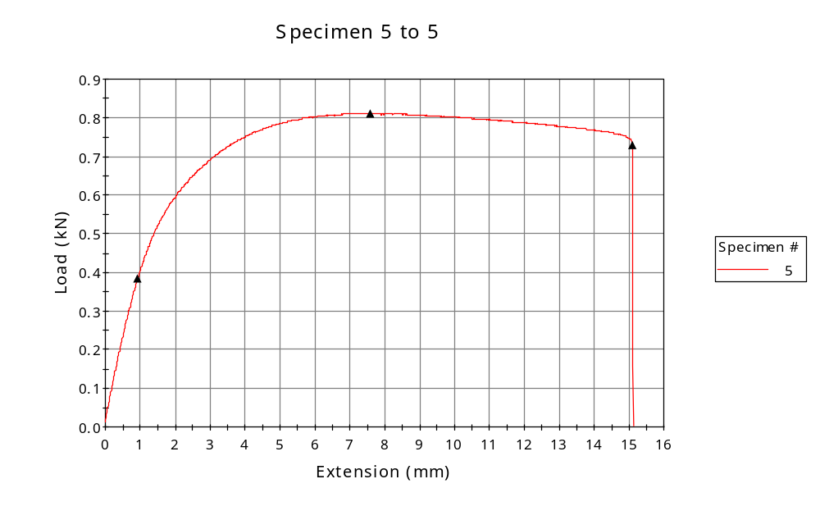

 | CP ID | Length  (mm) | Width  (mm) | Thickness  (mm) | Modulus (Automatic Young's)  (MPa)
1 | CP-SLS_XZ2_01 | 25.00 | 6.04 | 3.28 | 1459
2 | CP-SLS_XZ2_02 | 25.00 | 6.03 | 3.26 | 1432
3 | CP-SLS_XZ2_03 | 25.00 | 6.04 | 3.45 | 1362
4 | CP-SLS_XZ2_04 | 25.00 | 6.09 | 3.39 | 1373
5 | CP-SLS_XZ2_05 | 25.00 | 6.08 | 3.33 | 1358
Maximum |  | 25.00 | 6.09 | 3.45 | 1459
Minimum |  | 25.00 | 6.03 | 3.26 | 1358

 | Load at Fy ( 0.2 %) - LE  (kN) | Tensao em Fy ( 0.2 %) - LE  (MPa) | Deformacao em Fy ( 0.2 %) - LE  (%) | Forca Max  (kN) | Tensao na Forca Max - LR  (MPa)
1 | 0.364 | 18 | 1.448 | 0.808 | 41
2 | 0.369 | 19 | 1.529 | 0.785 | 40
3 | 0.391 | 19 | 1.581 | 0.830 | 40
4 | 0.399 | 19 | 1.613 | 0.834 | 40
5 | 0.385 | 19 | 1.599 | 0.811 | 40
Maximum | 0.399 | 19 | 1.613 | 0.834 | 41
Minimum | 0.364 | 18 | 1.448 | 0.785 | 40

 | Deformacao na Forca Max - LR  (%) | Forca na Forca na Quebra - LQ  (kN) | Deformacao na Forca na Quebra - LQ  (%) | Final length  (mm) | Final width  (mm)
1 | 26.312 | 0.739 | 42.279 | 119.00 | 6.82
2 | 23.331 | 0.705 | 44.631 | 119.00 | 6.82
3 | 25.685 | 0.717 | 52.751 | 119.00 | 6.82
4 | 25.227 | 0.734 | 43.128 | 119.00 | 6.82
5 | 26.405 | 0.729 | 56.438 | 119.00 | 6.82
Maximum | 26.405 | 0.739 | 56.438 | 119.00 | 6.82
Minimum | 23.331 | 0.705 | 42.279 | 119.00 | 6.82

 | Alongamento
1 | 3.76
2 | 3.76
3 | 3.76
4 | 3.76
5 | 3.76
Maximum | 3.76
Minimum | 3.76

